**Sage**

**SAGE X3 PEOPLE LEAVE REPORTS**

**Technical Design Document**

**PR04 – ZLVEMED– Currently_on_Medial_Leave – UBA - NIGERIA**

Prepared by Mauritz Pieterse

# Change Record

|  |  |  |  |  |
| --- | --- | --- | --- | --- |
| Date | Author | Version | Change Reference | Naming Convention |
| 27/11/2017 | Alma Kaltwasser | 1.1 | Initial document |  |
|  |  |  |  |  |
|  |  |  |  |  |

# Distribution list

|  |  |  |  |  |
| --- | --- | --- | --- | --- |
| Name | Designated Business Area | Responsibility | Date | Method of Distribution |
|  |  |  |  |  |
|  |  |  |  |  |
|  |  |  |  |  |

# Naming Convention and Definitions

|  |  |
| --- | --- |
| Naming Convention | Definition |
|  |  |
|  |  |
|  |  |

**Contents**

A. Change Record 2

B. Distribution list 2

C. Naming Convention and Definitions 2

1 Executive Summary 4

2 Sample 5

3 Header 7

4 Columns 8

5 Grouping 9

6 Footer 9

7 Output 10

8 Selection 10

9 Totals 10

10 Restrictions 10

# Executive Summary

This technical design specification document is intended to describe the technical details that will be created for the Sage X3 People project for the report highlighted on the introduction page of this document.

In this document we address the intended fields that will be included on the report, as well as explanations for the elements implemented where applicable, restrictions to the report, possible clarification areas which will be documented on a new version of this document and suggestions to accommodate best practise which will by default be included to the TDD and can be removed if the suggestion is not accepted.

The areas covered in this document include:

* ZLVEMED

()

# Sample

The below sample is the expected result as provided by the client**.**

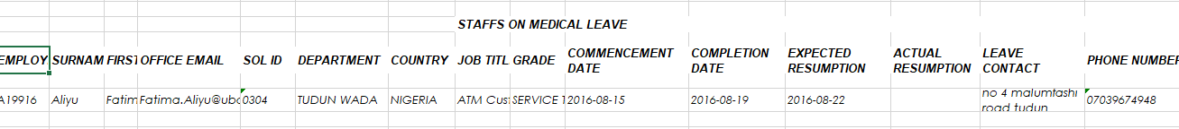

# Header

In the below section, various text and data boxes are required – Where a concatenation of the above is required, the data section of the requirement is specified between square brackets.

Text/Data box 1 - STAFFS ON MEDICAL LEAVE REPORT BETWEEN [datedeb] AND [datefin]

# Columns

**EMPLOYEENUMBER**

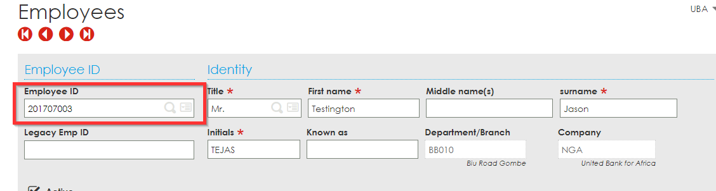

**EMPNAME –** Will be a concatenation of the below two fields, separated with a space.

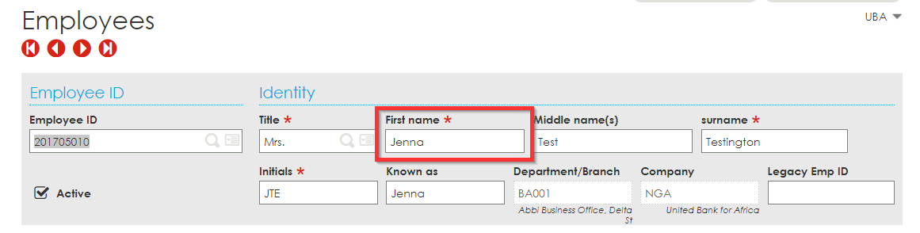

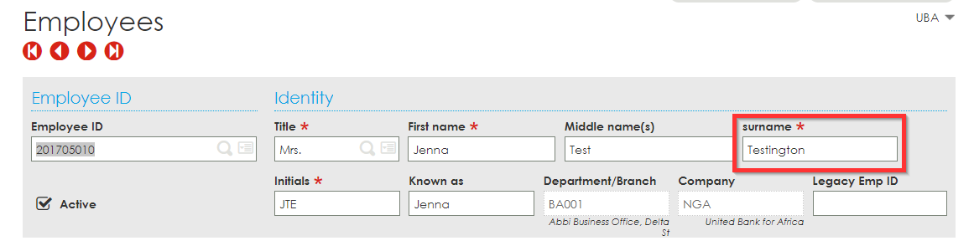

**OFFICE EMAIL**

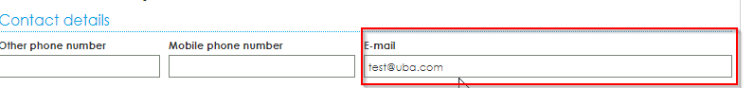

**SOL ID**

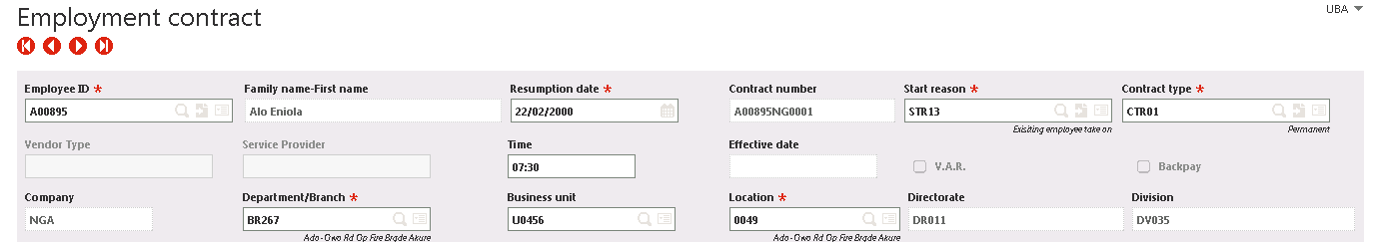

**DEPARTMENT**

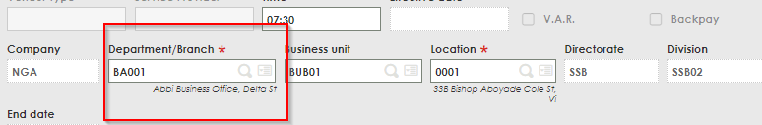

**COUNTRY**

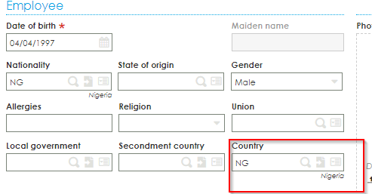

**JOB TITLE**

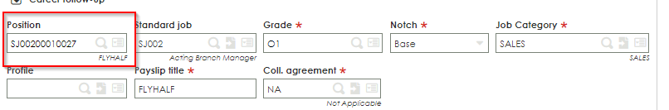

**GRADE**

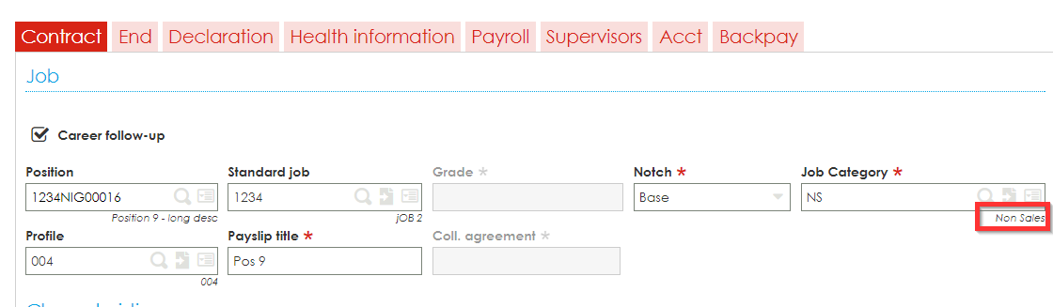

**COMMENCEMENTDATE**

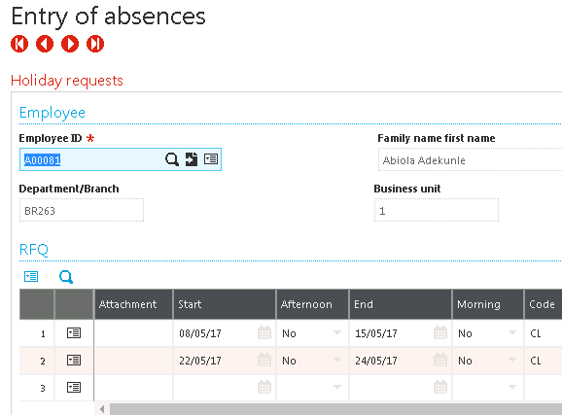

**COMPLETIONDATE**



**EXPECTEDRESUMPTIONDATE**

This would be the End date + 1

**ACTUAL RESUMPTION DATE**

This would be the End date + 1

**LEAVE CONTACT ADDRESS**

Are you looking for the Relief Address of for the address where the employee will be during his/her leave period?

**LEAVE CONTACT PHONE NUMBER**

Relief or the employee

# Grouping

A grouping by employee is required for this report since supplementary payroll “runs” could have an impact on this.

# Footer

# Output

This report will be executed as a crystal report. The report output can be found by going to the following location within sage.

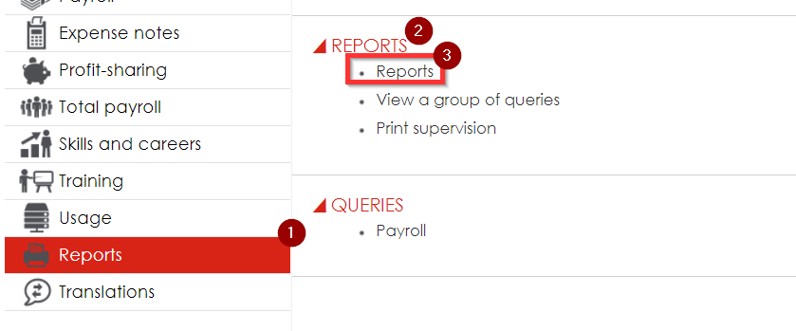

# Selection

Leave Catergory

Date From

Date To

--Based on Current Date:

# Totals

# Restrictions

None